Statistics

1. Data types in statistics
2. Categorical and Numerical
3. Levels of data

* Nominal level
* Ordinal level
* Interval level
* Ratio level

1. Population
2. Sample
3. Population vs Sample
4. Inferential statistics
5. Frequency table class vs frequency
6. Relative frequency table
7. Bar chart
8. Pie chart
9. Frequency distributed table CI vs Interval freq
10. Histogram
11. Distribution graph
12. Central tendency
13. Mean- Median-mode
14. Mean vs Median
15. Outliers
16. Skewed data
17. Pos – Neg – normal
18. Bi mode – Uni mode – Multi mode
19. Data dispersion
20. Range It will not consider middle value
21. Mean deviation ; Total deviation =0
22. AMD : graph is dis cont at point zero
23. Variance : value will be raise as well as units also
24. Standard deviation
25. Variance : how a data is varying it self
26. Covariance: how a data is varying w.r.t other variable
27. Pos or neg or neutral
28. Covariance Matrix

Python certification : Post LinkdIN

GenAI certification free

Covariance will give only it has positive relation or negative relation od No relation

But it will not provide how much is the relation

Pearson Correlation Coefficient ( r) :

Variance Covariance Std

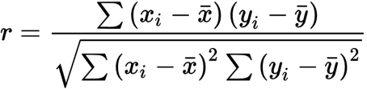

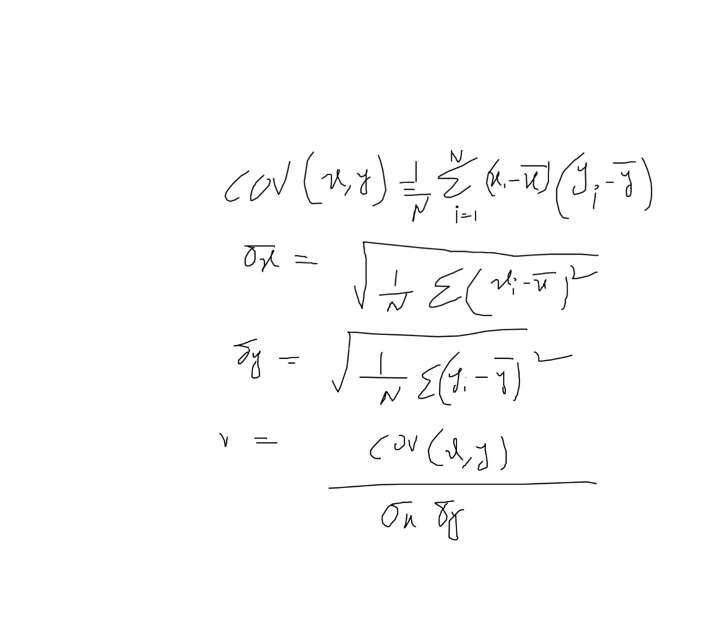

**$2,038 $1,758 $1,721 $1,637 $2,097 $2,047 $2,205 $1,787 $2,287 $1,940 $2,311 $2,054 $2,406 $1,471 $1,460**

**25p 50p 75p**

**1460 1471 1637 1721 1758**

**1787 1940 2038 2047 2057**

**2097 2205 2287 2311 2406**

**Step-1: Arrange ascending or descending**

**Step-2: Count the number of observation**

**Step-3: Calculate the position 25p = 3.75 4th pos = 1721**

**50= 8th pos =2038**

**75= 11.25 12th = 2025**

**Formulae to Find the Position N P 100 : P*(N+1)/100**



**Data coverage is our main concept, not the values**



